

**Group Meeting #6**

The meeting of TeamSix has decided at Discord at 11th April 2021.

**Attend present**

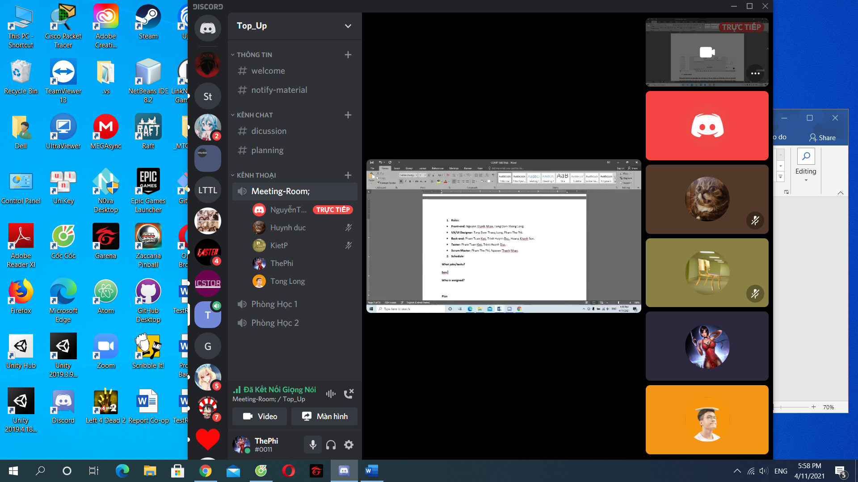

**There is 5 members in meeting:**

Pham The Phi

Trinh Huynh Duc

Tong Dam Thang Long

Pham Tuan Kiet

Nguyen Hoang Nhan

**Member Not Attendance**

Hoang Khanh Son

**Report about**

**Discuss about Manager’s function, Report project and product presentation.**

**Time Meeting**

An initial team discussion about the project was held on 11th April, 2021 at 17h30.

**Approve comments during the meeting**

Son and Duc have trouble getting the code in manager's function. Nhan and Long are also difficult to use front-end code in conjunction with functional code.

**Unfinished Work**

Manager’s function.

**Next Work**

The work will end. Everyone has more time to complete their work more carefully.

**Work progress**

Manager’s function not done yet.